Compiler Construction Project – Phase 1: Lexical Analyzer
By Nauman Irshad ali Shah
Refer No. : L1f22bscs0122

youtube video link ::: https://youtu.be/2bxd5YWMU80?si=Ffhw70ql2J-Owe26
github link ::: https://github.com/Nauman-Irshad/cc-project-Nauman-irshad-0122/blob/main/video%20cc%20project%20working%20nauman%200122.mp4

Objective:
In Phase 1, I designed and implemented a lexical analyzer for a Mini C++-like language using Flex, which I called the Urdu Script Lexical Analyzer. I used my own Urdu-style keywords such as:

hum, tum, Wapas, Agar, Adadi, Mantiqi, shuru, khatam, jabtak, warna, magar, wo, socho, dalo, rahko, pakka, aur, keliye, lo, sahi, galat, ya, nahi, kaam, wapis, hatao

Features of My Lexical Analyzer:

- TokenRecognition:
My analyzer identifies and classifies all types of tokens:
- Identifiers: Variables and function names (regex: [a-zA-Z_][a-zA-Z0-9_]*)
- Numbers: Integers ([+-]?[0-9]+), floats ([+-]?[0-9]*\.[0-9]+), and exponential forms ([0-9]+([Ee][+-]?[0-9]+))
- Keywords: My 25 unique Urdu-style keywords (regex: exact string match for each keyword)
- Operators: Includes +, -, *, /, %, =, +=, ==, etc. (regex: exact match for each operator)
- Punctuations: {, }, (, ), ;, :: (regex: exact match for each punctuation)
- Strings: Enclosed in double quotes (regex: "[^"\n]*")

- Error Handling:
Invalid tokens are detected and reported with descriptive error messages. For example:
- Line 7: ERROR → @salary (invalid identifier)
- Line 15: ERROR → 12ab (invalid number format)
- Line 20: ERROR → 'abc' (character literal too long)
- Line 35: INVALID_IDENTIFIER -> #third (ERROR: identifier cannot start with special character)
- Line 35: INVALID_IDENTIFIER -> $price (ERROR: identifier cannot start with special character)
- Line 35: INVALID_IDENTIFIER -> %rate (ERROR: identifier cannot start with special character)
- Line 35: INVALID_IDENTIFIER -> ^exp (ERROR: identifier cannot start with special character)
- Line 35: INVALID_IDENTIFIER -> &mem (ERROR: identifier cannot start with special character)
- Line 35: INVALID_IDENTIFIER -> *data (ERROR: identifier cannot start with special character)

- Uniqueness:
- I designed 25 unique keywords, inspired by Urdu terms that map to programming constructs ( shuru for start, khatam for end, Mantiqi for logical operations).
- I selected operators (+, =, ++) and punctuations ({, ::) that are essential for expression parsing.
- I wrote a unique test program of over 220 lines using these keywords, ensuring originality.

- Regex Implementation:
- Keywords: Exact string match for each keyword in the keywords[] array.
- Identifiers: [a-zA-Z_][a-zA-Z0-9_]*
- Integers: [+-]?[0-9]+
- Floats: [+-]?[0-9]*\.[0-9]+
- Exponentials: [0-9]+([Ee][+-]?[0-9]+)
- Operators and punctuations: Exact string matches for each symbol.
- Strings: "[^"\n]*"

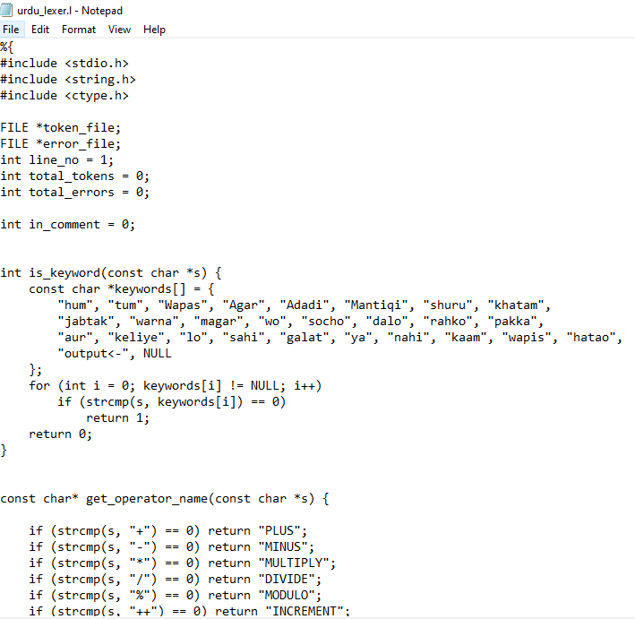

Project Description

Tokenization

Identifiers:

# | Identifier | Valid/Invalid | Notes / Reason | Regex Check (C++ Identifier)
1 | valid123 | Valid | Letters + digits | [a-zA-Z_][a-zA-Z0-9_]*
2 | abc123def | Valid | Letters + digits | [a-zA-Z_][a-zA-Z0-9_]*
3 | 123start | Invalid | Starts with digit | [a-zA-Z_][a-zA-Z0-9_]*
4 | @begin | Invalid | Starts with special character @ | [a-zA-Z_][a-zA-Z0-9_]*
5 | variable123 | Valid | Letters + digits | [a-zA-Z_][a-zA-Z0-9_]*
6 | file_path | Valid | Underscores allowed | [a-zA-Z_][a-zA-Z0-9_]*
7 | hello-world | Invalid | Contains hyphen - | [a-zA-Z_][a-zA-Z0-9_]*
8 | param1 | Valid | Simple parameter | [a-zA-Z_][a-zA-Z0-9_]*
9 | $variable | Invalid | Starts with $ | [a-zA-Z_][a-zA-Z0-9_]*
10 | totalCount | Valid | CamelCase | [a-zA-Z_][a-zA-Z0-9_]*
11 | !invalid | Invalid | Starts with ! | [a-zA-Z_][a-zA-Z0-9_]*
12 | counter | Valid | Simple word | [a-zA-Z_][a-zA-Z0-9_]*
13 | space here | Invalid | Contains space | [a-zA-Z_][a-zA-Z0-9_]*
14 | avgScore | Valid | CamelCase | [a-zA-Z_][a-zA-Z0-9_]*

- Numbers (integers, floats, exponential forms):

# | Number Type | Regex Pattern | Example | Description
1 | Integer | [0-9]+ | 123, 0, 456 | Whole numbers without decimal point
2 | Floating-point | [0-9]*\.[0-9]+ | 3.14, 0.5, .25 | Numbers with decimal point
3 | Exponential form | [0-9]+(\.[0-9]+)[Ee][+-]?[0-9]+ | 1.5E3, 2e-4 | Numbers in scientific notation

- Keywords : (24 Keywords)

Keyword | Meaning | Example in Urdu -Script -like Urdu Script
hum | Declare a variable / start | hum x = 5;
tum | Input variable | tum y;
Wapas | Return statement | Wapas x;
Agar | If condition | Agar (x > 0) { ... }
Adadi | Numeric type (int/float) | Adadi num = 10;
Mantiqi | Logical operator / condition | Mantiqi result = (x && y);
shuru | Start block / function | shuru { ... }
khatam | End block / function | khatam
jabtak | While loop | jabtak (x < 10) { ... }
warna | Else / alternative | warna { ... }
magar | But / exception | magar (x != 0) { ... }
wo | Pointer / reference | wo ptr = &x;
socho | Read / input statement | socho x;
dalo | Assign / put value | dalo x = 20;
rahko | Keep / store | rahko y = x;
pakka | Constant / final | pakka pi = 3.14;
aur | And operator | aur (x && y)
keliye | For loop | keliye (i=0; i<5; i++) { ... }
lo | Take / fetch value | lo x = num;
sahi | True / correct | Mantiqi flag = sahi;
galat | False / incorrect | Mantiqi flag = galat;
ya | Or operator | ya (x
nahi | Not operator | nahi (x)
kaam | Function call / operation | kaam doSomething();

- Operators:(20 Operators)

Operator | Type / Notes
+ | PLUS
- | MINUS
* | MULTIPLY
/ | DIVIDE
% | MODULO
++ | INCREMENT
-- | DECREMENT
= | ASSIGN
+= | PLUS_ASSIGN
-= | MINUS_ASSIGN
*= | MULTIPLY_ASSIGN
/= | DIVIDE_ASSIGN
%= | MODULO_ASSIGN
<<= | LEFT_SHIFT_ASSIGN
>>= | RIGHT_SHIFT_ASSIGN
&= | BITWISE_AND_ASSIGN
^= | BITWISE_XOR_ASSIGN
` | =`
== | EQUAL
!= | NOT_EQUAL
> | GREATER
< | LESS
>= | GREATER_EQUAL
<= | LESS_EQUAL

- Punctuations:(11 Punctuations)

S.No | Punctuation | Token Type
1 | ; | SEMICOLON
2 | , | COMMA
3 | ( | LEFT_PAREN
4 | ) | RIGHT_PAREN
5 | { | LEFT_BRACE
6 | } | RIGHT_BRACE
7 | [ | LEFT_BRACKET
8 | ] | RIGHT_BRACKET
9 | : | COLON
10 | ? | QUESTION

- Strings and Characters:

S.No | Pattern / Lexeme | Token Type | Notes / Description
1 | "[^"\n]*" | STRING | Valid string literal enclosed in double quotes
2 | "[^"\n]* | INVALID_STRING | Unterminated string literal
3 | '[^'\\\n]' | CHAR | Valid character literal enclosed in single quotes
4 | '\\[nrt0abfv\\'\"]' | CHAR | Valid escaped character
5 | '\\[^nrt0abfv\\'\"]' | INVALID_CHAR | Invalid escape sequence in character literal
6 | '[^'\n]*' | INVALID_CHAR | Character literal too long

Each token must be printed in the format:
Line <n>: <TOKEN_TYPE> → <lexeme>

My Examples:

- Line 2: KEYWORD -> Adadi
- Line 2: IDENTIFIER -> kya_yeh_kalima
- Line 2: LEFT_PAREN -> (
- Line 2: IDENTIFIER -> const
- Line 2: IDENTIFIER -> char
- Line 2: RIGHT_PAREN -> )
- Line 2: LEFT_BRACE -> {
- Line 3: IDENTIFIER -> const
- Line 3: IDENTIFIER -> char
- Line 3: LEFT_BRACKET -> [

Line Tracking

Report the line number for each token
- Line 19: SEMICOLON -> ;
- Line 20: RIGHT_BRACE -> }
- Line 22: KEYWORD -> Adadi
- Line 22: KEYWORD -> shuru
- Line 22: LEFT_PAREN -> (
- Line 22: RIGHT_PAREN -> )
- Line 22: RIGHT_PAREN -> )

Error Handling
- Invalid tokens must be reported as errors with their line numbers.

- Line 2: INVALID_IDENTIFIER -> *lafz (ERROR: identifier cannot start with special character)
- Line 3: INVALID_IDENTIFIER -> *kalimat (ERROR: identifier cannot start with special character)
- Line 23: INVALID_NUMBER_MULTIPLE_EXPONENTS -> "Roman Urdu Keyword Check Shuru Hua\\n" (ERROR: invalid number - multiple exponents)
- Line 33: INVALID_NUMBER_FORMAT -> 123start (ERROR: identifier cannot start with digit)
- Line 33: INVALID_IDENTIFIER -> @begin (ERROR: identifier cannot start with special character)
- Line 33: INVALID_IDENTIFIER -> #first (ERROR: identifier cannot start with special character)
- Line 33: INVALID_IDENTIFIER -> $variable (ERROR: identifier cannot start with special character)
- Line 33: INVALID_IDENTIFIER -> %percent (ERROR: identifier cannot start with special character)
- Line 33: INVALID_IDENTIFIER -> ^caret (ERROR: identifier cannot start with special character)
- Line 33: INVALID_IDENTIFIER -> &ref (ERROR: identifier cannot start with special character)
- Line 33: INVALID_IDENTIFIER -> *ptr (ERROR: identifier cannot start with special character)
- Line 34: INVALID_NUMBER_FORMAT -> 456end (ERROR: identifier cannot start with digit)
- Line 34: INVALID_IDENTIFIER -> @test (ERROR: identifier cannot start with special character)
- Line 34: INVALID_IDENTIFIER -> #second (ERROR: identifier cannot start with special character)
- Line 34: INVALID_IDENTIFIER -> $money (ERROR: identifier cannot start with special character)
- Line 34: INVALID_IDENTIFIER -> %value (ERROR: identifier cannot start with special character)
- Line 34: INVALID_IDENTIFIER -> ^power (ERROR: identifier cannot start with special character)
- Line 34: INVALID_IDENTIFIER -> &addr (ERROR: identifier cannot start with special character)
- Line 34: INVALID_IDENTIFIER -> *pointer (ERROR: identifier cannot start with special character)
- Line 35: INVALID_NUMBER_FORMAT -> 789middle (ERROR: identifier cannot start with digit)
- Line 35: INVALID_IDENTIFIER -> @var (ERROR: identifier cannot start with special character)
- Line 35: INVALID_IDENTIFIER -> #third (ERROR: identifier cannot start with special character)

- Line 35: INVALID_IDENTIFIER -> $price (ERROR: identifier cannot start with special character)
- Line 35: INVALID_IDENTIFIER -> %rate (ERROR: identifier cannot start with special character)
- Line 35: INVALID_IDENTIFIER -> ^exp (ERROR: identifier cannot start with special character)
- Line 35: INVALID_IDENTIFIER -> &mem (ERROR: identifier cannot start with special character)
- Line 35: INVALID_IDENTIFIER -> *data (ERROR: identifier cannot start with special character)
- Line 36: INVALID_NUMBER_FORMAT -> 012begin (ERROR: identifier cannot start with digit)
- Line 36: INVALID_NUMBER -> @123 (ERROR: invalid number - cannot start with special character)
- Line 36: INVALID_NUMBER -> #456 (ERROR: invalid number - cannot start with special character)
- Line 36: INVALID_NUMBER -> $789 (ERROR: invalid number - cannot start with special character)
- Line 36: INVALID_NUMBER -> %012 (ERROR: invalid number - cannot start with special character)
- Line 36: INVALID_NUMBER -> ^345 (ERROR: invalid number - cannot start with special character)
- Line 36: INVALID_NUMBER -> &678 (ERROR: invalid number - cannot start with special character)
- Line 36: INVALID_NUMBER -> *901 (ERROR: invalid number - cannot start with special character)
- Line 37: INVALID_IDENTIFIER -> @abc123 (ERROR: identifier cannot start with special character)
- Line 37: INVALID_IDENTIFIER -> #def456 (ERROR: identifier cannot start with special character)
- Line 37: INVALID_IDENTIFIER -> $ghi789 (ERROR: identifier cannot start with special character)
- Line 37: INVALID_IDENTIFIER -> %jkl012 (ERROR: identifier cannot start with special character)
- Line 37: INVALID_IDENTIFIER -> ^mno345 (ERROR: identifier cannot start with special character)
- Line 37: INVALID_IDENTIFIER -> &pqr678 (ERROR: identifier cannot start with special character)
- Line 37: INVALID_IDENTIFIER -> *stu901 (ERROR: identifier cannot start with special character)
- Line 38: INVALID_NUMBER_FORMAT -> 123abc456 (ERROR: identifier cannot start with digit)
- Line 38: INVALID_NUMBER -> @123abc (ERROR: invalid number - cannot start with special character)
- Line 38: INVALID_NUMBER -> #456def (ERROR: invalid number - cannot start with special character)

Uniqueness Requirement

Unique Keywords:

I designed 25 Urdu-script keywords for my Mini C-like language. These include:

hum, tum, Wapas, Agar, Adadi, Mantiqi, shuru, khatam, jabtak, warna, magar, wo, socho, dalo, rahko, pakka, aur, keliye, lo, sahi, galat, ya, nahi, kaam, wapis, hatao,

Unique Operators:
I defined custom operators in addition to common ones:

Standard operators: +, -, *, /, =

Additional operators: ++, --, +=, <-, =~

Unique Punctuations:
I chose punctuations that are commonly used in C++, but for uniqueness, my program emphasizes:
; | SEMICOLON
, | COMMA
( | LEFT_PAREN
) | RIGHT_PAREN
{ | LEFT_BRACE
} | RIGHT_BRACE
[ | LEFT_BRACKET
] | RIGHT_BRACKET
: | COLON
? | QUESTION

Why it’s unique:

These keywords are based on Urdu words to make the language more readable in a regional style with error detection

Operators like <- and =~ are not standard C++ operators, which makes my language different

Each keyword has a specific meaning in code, shuru = start of program, khatam = end, Wapas = return..
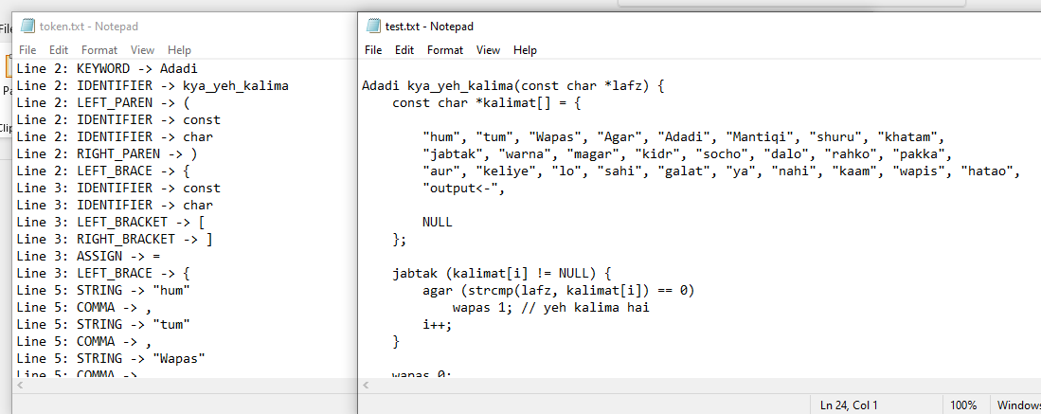

Unique Sample Program:

I wrote a 220 line Mini C++-like program using these keywords, operators, and punctuations.

The program uses my Urdu-style syntax and cannot be confused with other students’ programs.

Example test lines:

Adadi kya_yeh_kalima(const char *lafz) {

const char *kalimat[] = {

"hum", "tum", "Wapas", "Agar", "Adadi", "Mantiqi", "shuru", "khatam",

"jabtak", "warna", "magar", "kidr", "socho", "dalo", "rahko", "pakka",

"aur", "keliye", "lo", "sahi", "galat", "ya", "nahi", "kaam", "wapis", "hatao",

"output<-",

NULL

};

@1 @2 @3 @4 @5 @6 @7 @8 @9 @0

#a #b #c #d #e #f #g #h #i #j

valid123 + @invalid * 45.67.89 / #wrong

"proper string" + 'bad char' * 12.34.56 / @test

@@ ## $$ %% ^^ && ** (()) << >>

+++ --- *** /// \\\ <<< >>> ===

123start @begin #first $variable %percent ^caret &ref *ptr

456end @test #second $money %value ^power &addr *pointer

789middle @var #third $price %rate ^exp &mem *data

012begin @123 #456 $789 %012 ^345 &678 *901

+++ --- *** /// \\\ <<< >>> === !== >=< <=>

&&& ||| !!! ??? ::: ... ,,, ;;;

@#!$%^&*()_+-=[]\{}|;':",./<>? 123abc 45.67.89 "unclosed 'char" /* unfinished

+++ --- *** /// \\\ <<< >>> === []] {{} ;: ?. ,, .. @1 #a $2 %b ^c &d *e

"backslash \\\\\\ too many"

"mixed \x\y\z invalid"

123ab+ 45.67.89 * @invalid / #wrong % $error

"string" + 'char' * 12.34.56 / @test #value $result

// single line comment with // inside

// another // comment // with // multiple // slashes

/// triple slash

//// four slashes

Sample tokens keywords:

hum, tum, Wapas, Agar, Adadi, Mantiqi, shuru, khatam, jabtak, warna, magar, wo, socho, dalo, rahko, pakka, aur, keliye, lo, sahi, galat, ya, nahi, kaam, wapis, hatao,

TOKEN With Regex Defination

Token Type | Regex | Description
Keywords | "hum", "tum", "Wapas", "Agar", "Adadi", "Mantiqi", "shuru", "khatam", "jabtak", "warna", "magar", "wo", "socho", "dalo", "rahko", "pakka", "aur", "keliye", "lo", "sahi", "galat", "ya", "nahi", "kaam", "wapis", "hatao", "output<-" | Reserved Urdu-style keywords.
Identifier | [a-zA-Z_][a-zA-Z0-9_]* | Valid variable or function names.
Invalid Identifier | [@#$%^&*][a-zA-Z_][a-zA-Z0-9_]* | Identifiers starting with special symbols.
Integer Number | [+-]?[0-9]+ | Whole numbers with optional sign.
Floating Number | [0-9]*\.[0-9]+([Ee][+-]?[0-9]+)? | Decimal numbers, optional exponential.
Exponential Number | [0-9]+([Ee][+-]?[0-9]+) | Scientific notation numbers.
Invalid Number (multiple dots) | [0-9]+(\.[0-9]+){2,} | Numbers with multiple decimal points.
Invalid Number (multiple exponents) | [0-9]+([Ee][+-]?[0-9]+){2,} | Numbers with multiple exponential parts.
Invalid Mixed Number | [0-9]+[a-zA-Z_]+[a-zA-Z0-9_]* | Numbers mixed with letters.
Operator | +, -, *, /, %, ++, --, =, +=, -=, *=, /=, %= ,<<=, >>=, &=, ^=, ` | =, ==, !=, >, <, >=, <=, &&,
Invalid Operator (consecutive) | +++, ---, ***, ///, \\\\ | Consecutive operators not allowed.
Punctuation | ;, ,, (, ), {, }, [, ], :, ?, . | Statement separators and block delimiters.
String Literal | "[^"\n]*" | Strings in double quotes.
Invalid String | "[^"\n]* | Unterminated string literal.
Character Literal | '[^'\\\n]', '\\[nrt0abfv\\'\"]' | Single characters, valid escape sequences.
Invalid Character | '[^'\n]*', '\\[^nrt0abfv\\'\"]' | Unterminated or invalid char literal.
Single-line Comment | //[^\n]* | Ignored content after //.
Multi-line Comment | /* ... */ | Ignored content between /* and */.
Whitespace | [ \t]+ | Spaces or tabs.
Newline | `\r\n | \n

- Draw finite automata (FA) diagrams for Identifiers and Numbers (hand- drawn or digital).
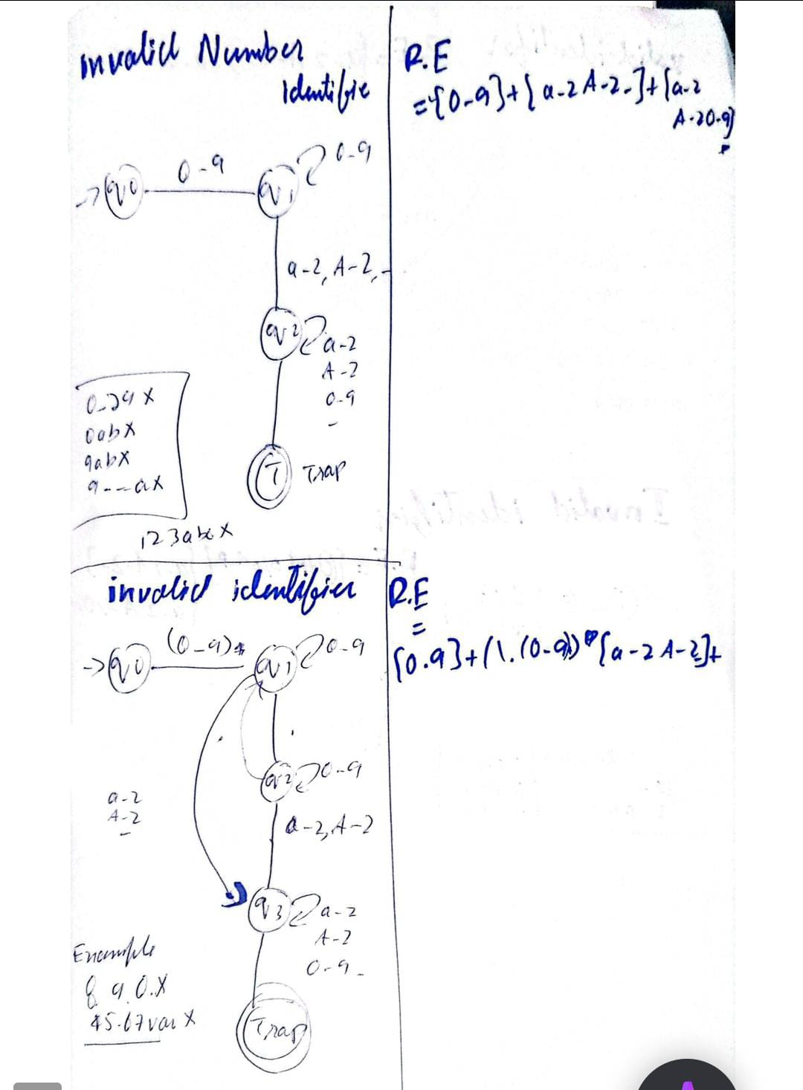
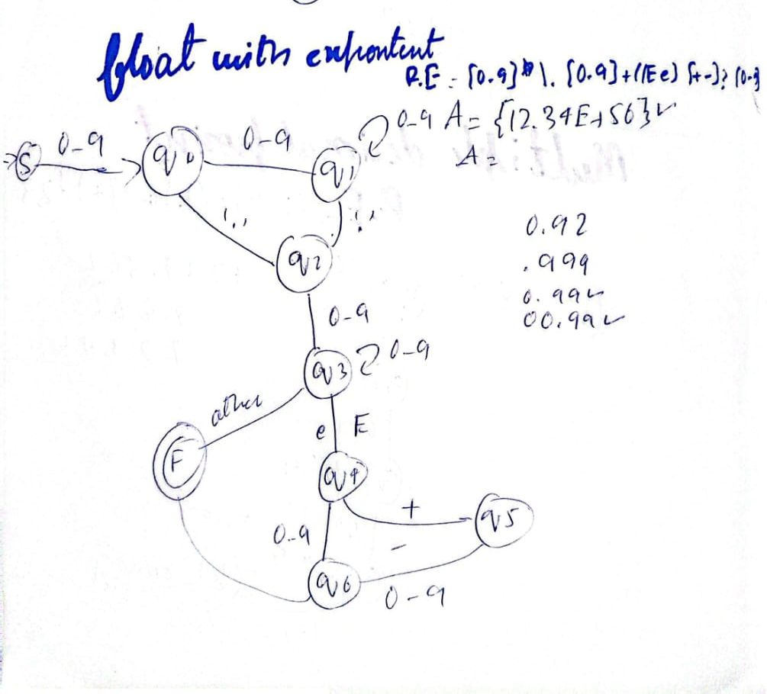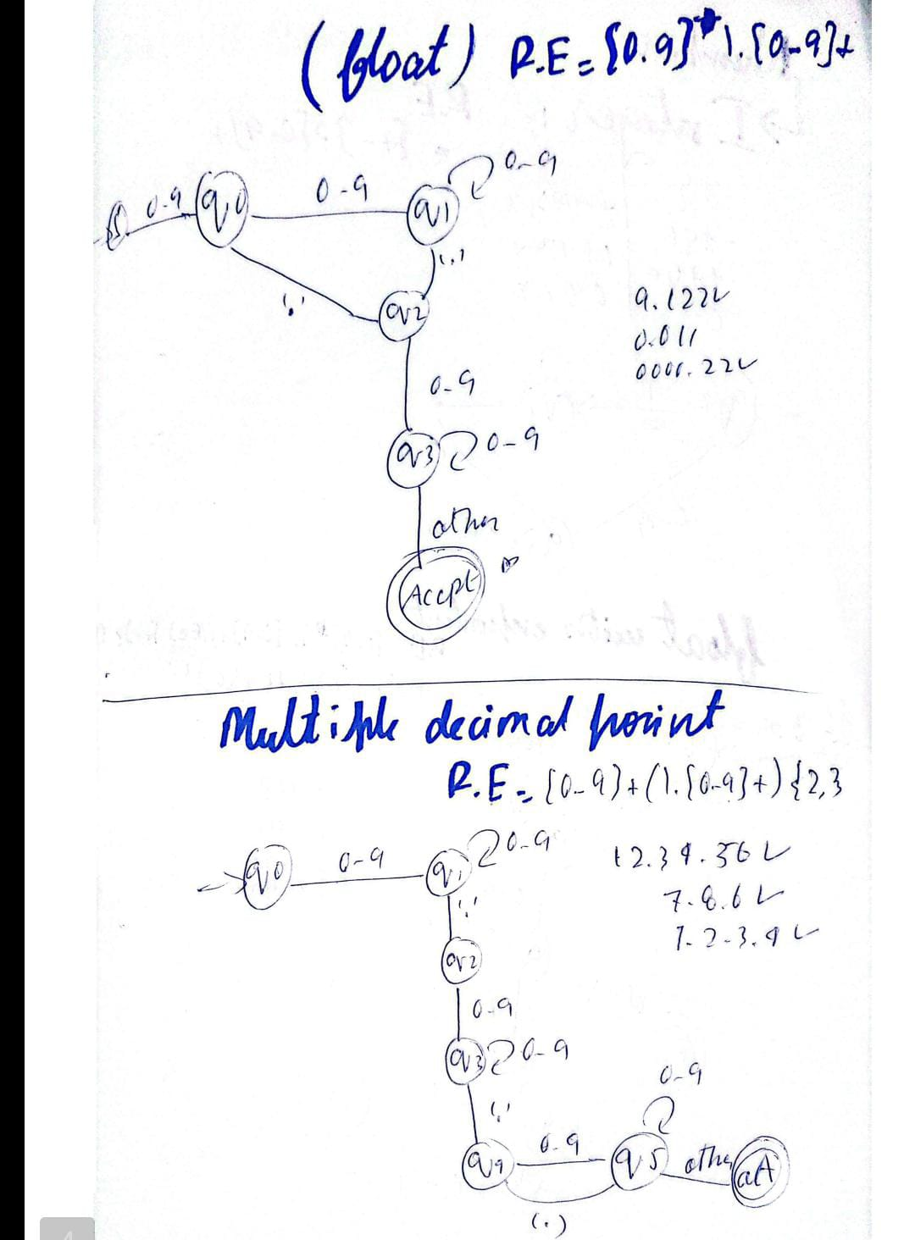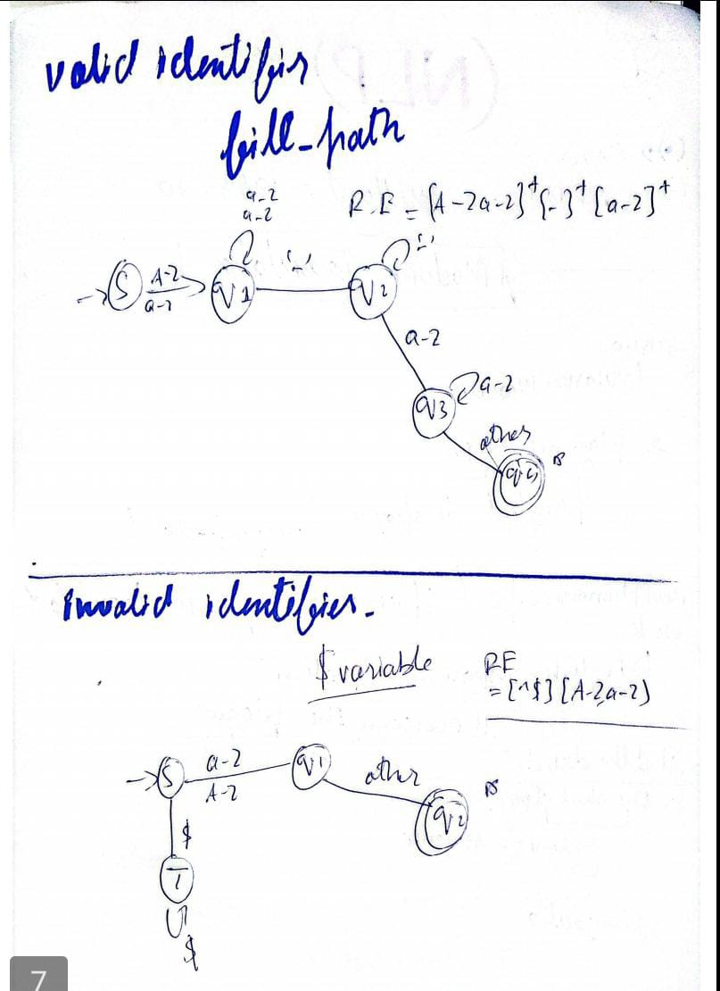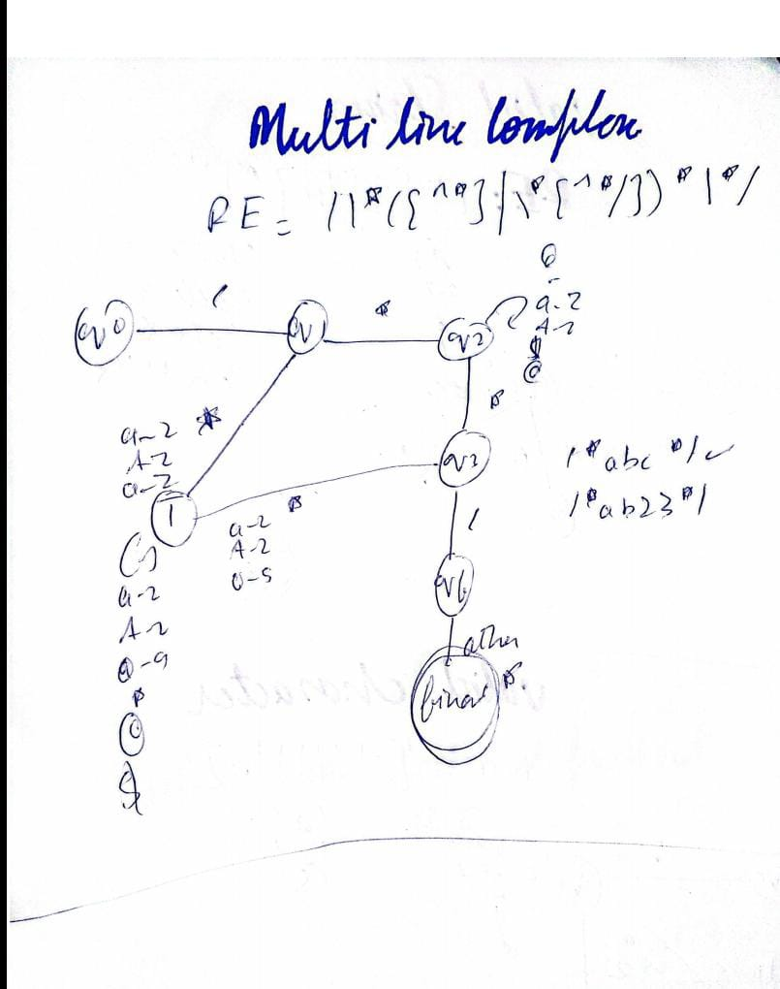

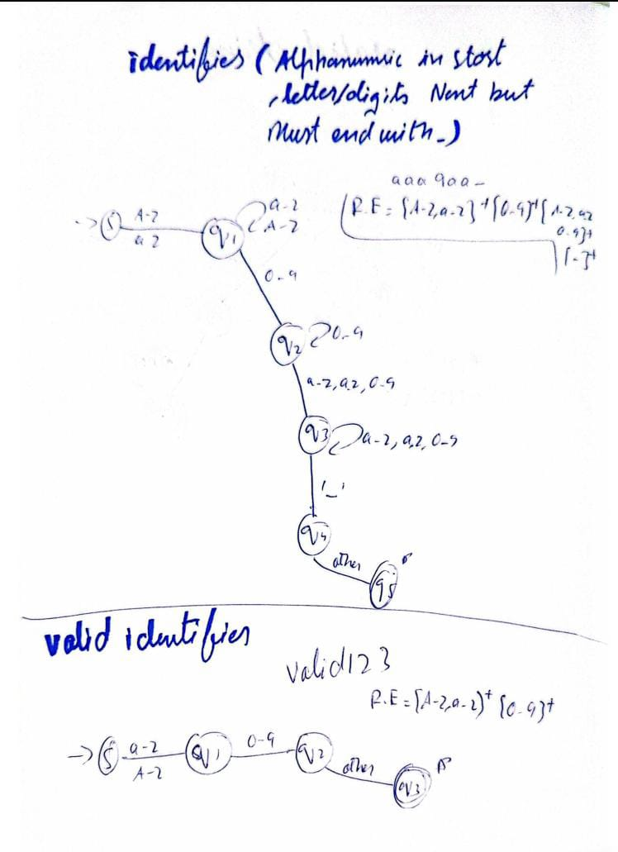

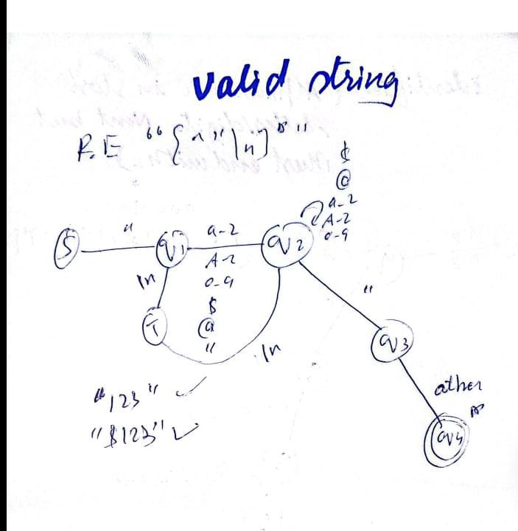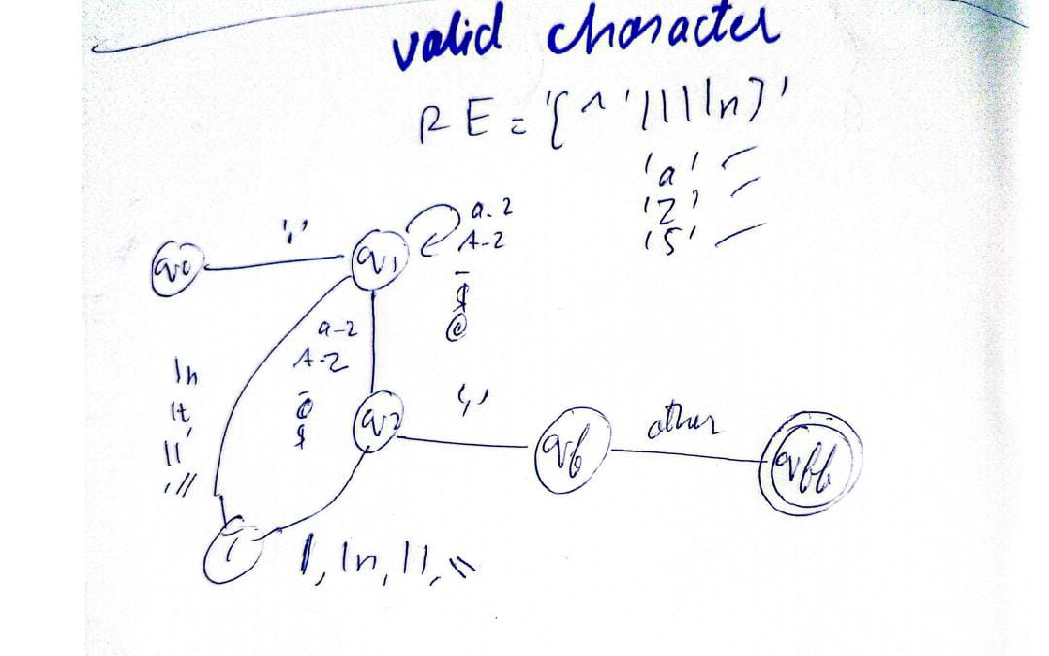

- Include a brief explanation of your choice of 25 keywords and why you designed them.

Keyword | Purpose / Meaning
hum | Represents the concept of “we” or default context, used for defining the main block or general scope.
tum | Represents “you”, could be used for user input or specific function scope.
Wapas | Acts as return in functions, signaling output of a value.
Agar | Conditional if statement.
Adadi | Represents numbers or numeric type, similar to int or float.
Mantiqi | Logical expressions, similar to boolean conditions.
shuru | Marks the start of a block, like {.
khatam | Marks the end of a block, like }.
jabtak | Represents a while or looping construct.
warna | Represents else in conditionals.
magar | Represents else if.
wo | Used for switch or selection statement.
socho | Represents read or input operations.
dalo | Represents write or output operations.
rahko | Used for continue statement in loops.
pakka | Used for break statement in loops.
aur | Logical AND operator.
keliye | Used in loops, similar to for.
lo | Assignment operator for special cases (output <-).
sahi | Represents true.
galat | Represents false.
ya | Logical OR operator.
nahi | Logical NOT operator.
kaam | Function keyword, similar to void.

Source Code

- Flex file (urdu_lexer.l) 700 lines of code.

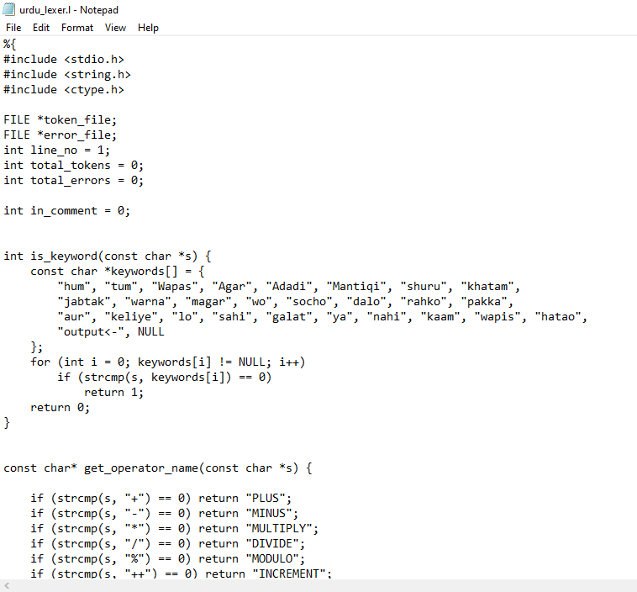

SAMPLE TEST.TXT
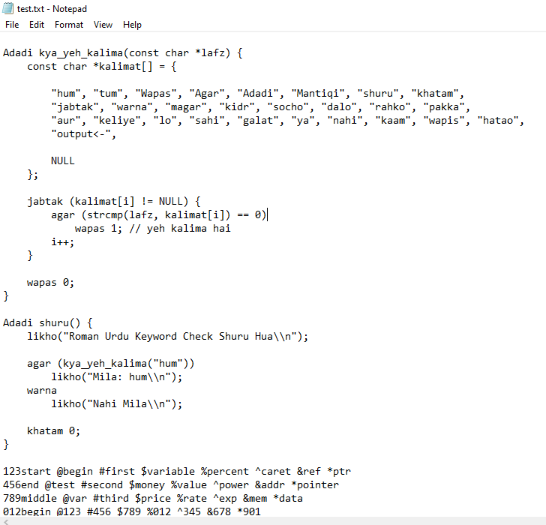

TOKEN.TXT
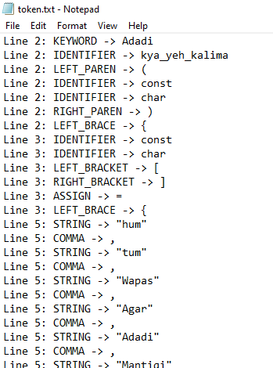
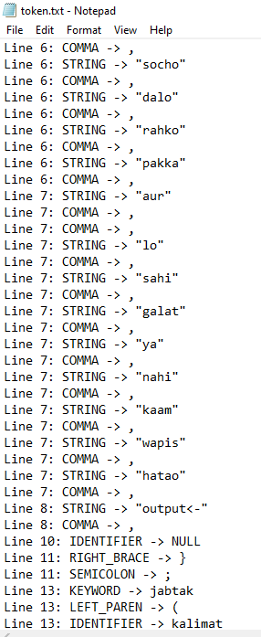

Error.txt

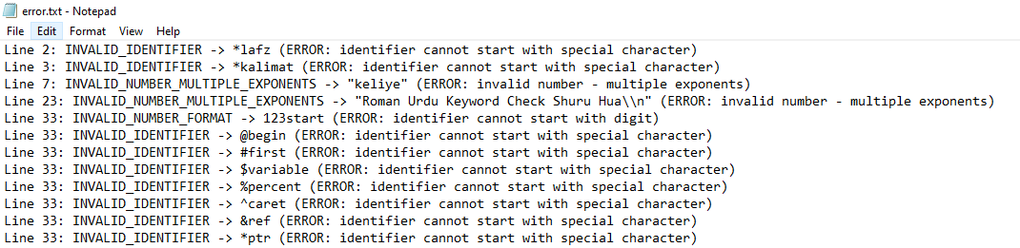

Demo Video (5 minutes max)

- Demonstrate running your scanner on your unique program.
- Explain how your regex works for at least 2 tokens.
- Highlight one error-handling ex

Rubrics (10 Marks)

Criteria | Marks | Description
Regex Definitions & Correctness | 2 | Regex table is complete, accurate, and handles edge cases.
Flex Implementation (Tokenization) | 2 | Scanner correctly recognizes tokens and prints them with line numbers.
Error Handling | 1 | Invalid tokens are reported with line numbers.
Uniqueness & Creativity | 3 | Student-designed 15 keywords + operators + punctuations, plus unique sample program.
Diagrams (FA for Identifier & Number) | 1 | Clear, correct diagrams provided.
Demo & Explanation (Video& Viva) | 1 | Student demonstrates execution and explains regex.

